

Egypt University of Informatics
Computer and Information Systems
Big Data Engineering Course

Technical Report
Data warehousing Design and Analytics Project

  - Submitted by:
  - Nada Ashraf 22-101043
  - Aly Zaki 22-101096
  - Ahmed Waleed 22-101058
  - Omar Bayoumi 22-101022

  - Submission Date: 19th April 2025

Introduction

This project is a data warehousing-based project in which we implement concepts such as a dimensional modelling like a star schema to design and implement a data warehouse in which we can extract insightful information that will help in the strategic decision making of our company. This project is focused on designing a complete historical data warehouse in which we go through the processes of developing a data warehouse undergoing phases like ETL process, OLAP Cube for analytics, and finally presenting our insights by using Power BI to translate data into information.
Project Overview
This project focuses on the sales performance of a fictional bicycle retail company called BikeStores. The goal is to analyze the historical sales data to uncover trends and insights across time, store locations, product lines, etc. By conducting this, the company will be able to achieve a strategic decision that will aid it in future decision-making and development.
Source Database Description
Sample Database: BikeStores Database
Includes key tables such as:
- Orders, order items, products, categories, brands, customers, staff, and stores.
- It has two areas of focus: Sales and Production
Source Database Entity-Relationship Diagram (ERD):
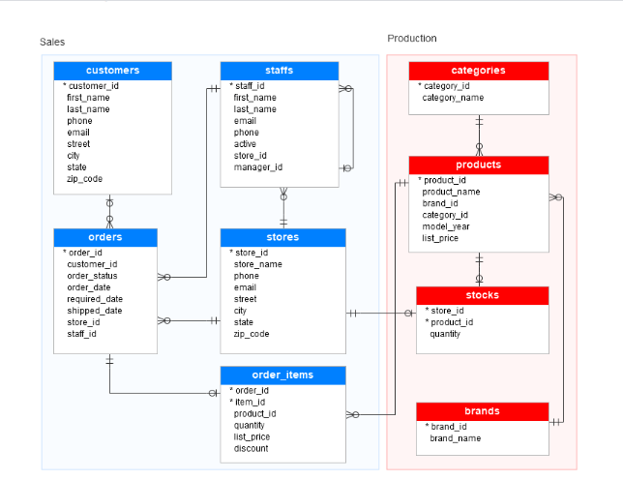

Datawarehouse Business Area Focus:
- Sales and Order
Datawarehouse Business Goals and Objectives:
- Analyze monthly sales trends to identify high-performing months.
- Determine which store generates the highest revenue.
- Identify top-selling bicycle products.
- Evaluate product categories by revenue and quantity sold.
- Identify top-performing salesperson staff based on total revenue.
- Identify which customers’ demographics generate the most revenue.
4 – Step in Designing a DW:
- Subject:
  - BikeStores Retail Sales
- Grain:
  - One row per product sold in a transaction per day per customer per staff per store.
  - For every product sold in a specific order, by a staff member, to a customer, in a store, on a specific day. (Transactional)
- Dimensions:
  - Product Dimension: Information related to products
  - Store Dimension: Information related to Stores.
  - Date Dimension: Hierarchy of Day, Month, and year.
  - Customer Dimension: Information related to Customer
  - Category Dimension: Information of product’s categories snow flaked from product dimension.
  - Brand Dimension: Information of product’s brand snow flaked from product dimension
  - Staff Dimension: Information related to salesperson that contributed to the sale.
- Measures:
  - Quantity Sold
  - Sales Amount (unit price * quantity * (1-discount))
  - Gross amount
  - Discount
Star Schema Design Visualization:
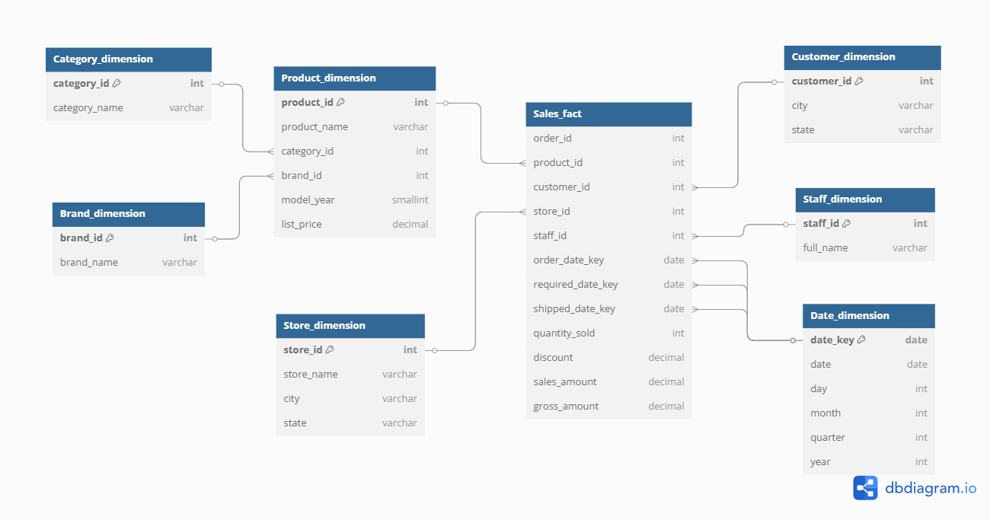
Methodology:
This project follows a structured methodology aligned with the general data warehousing lifecycle. Incorporating ETL development, OLAP cube design, MDX querying, and Power BI dashboard presentation.
Development Steps:
- Designing Data warehouse schema DDL
- An ETL pipeline was developed using SQL Server Integration Services (SSIS)
- OLAP Cube Development in SQL Server Analysis Services (SSAS)
- MDX queries were developed in SQL Server Management Studio (SSMS)
- Power BI Dashboard Creation from the cube developed.

Data warehouse Schema in SSMS (DDL):
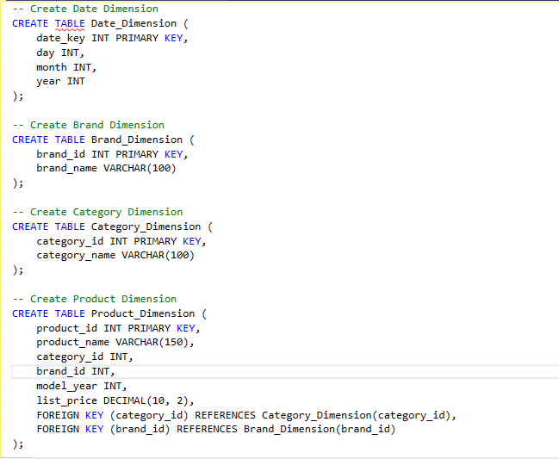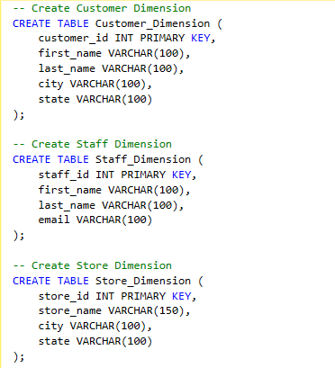

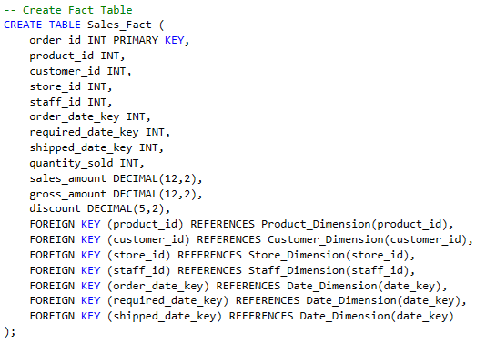

SSIS ETL Process Documentation:

Tools Used: Visual Studio 2019, SSIS

Product Dimension ETL
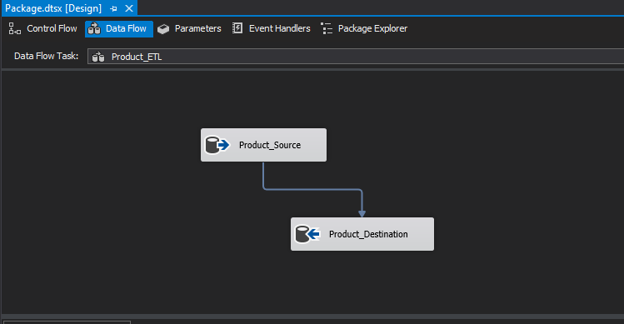

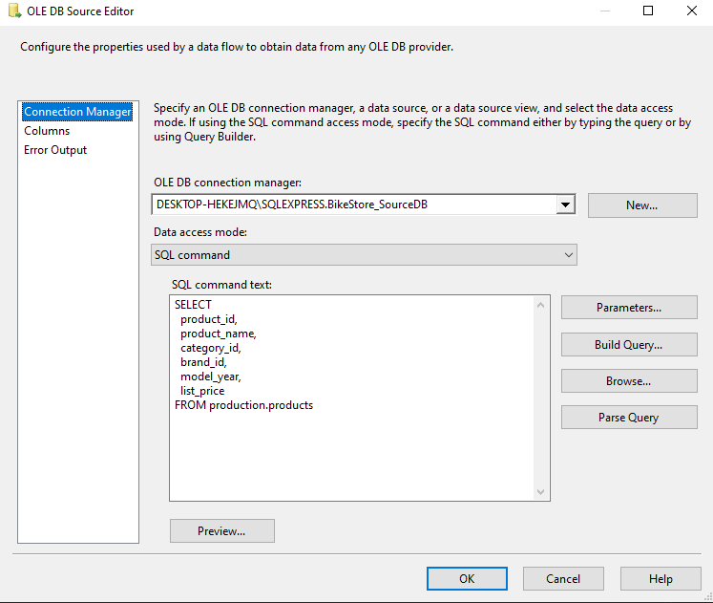

Customer Dimension ETL
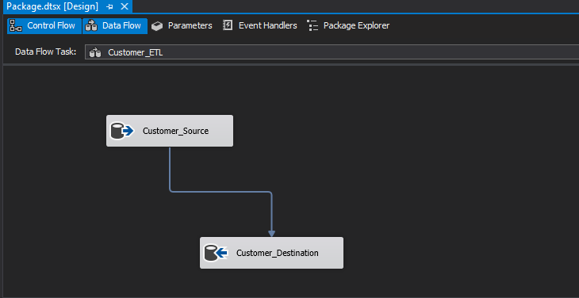

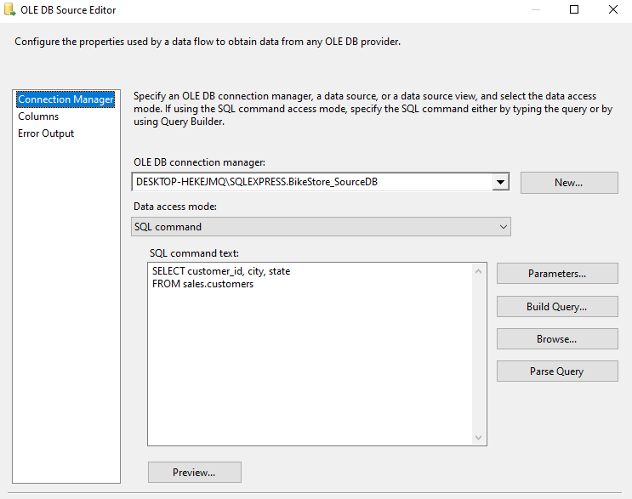

Store Dimension ETL
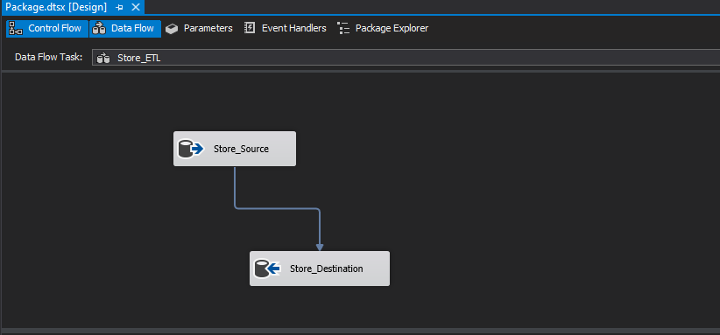

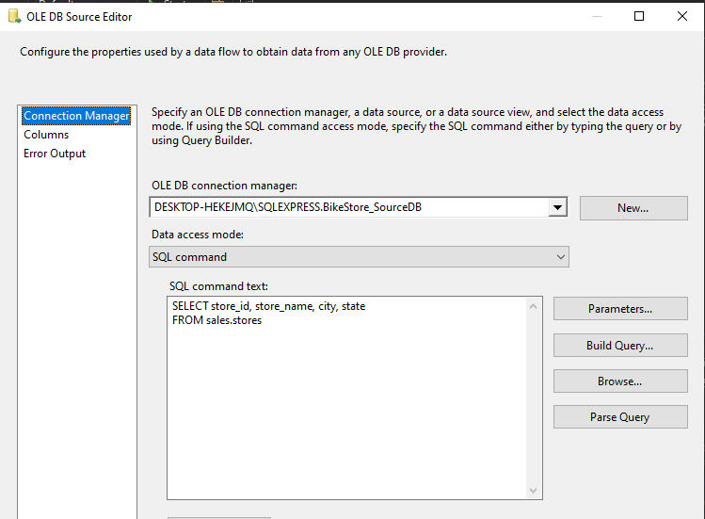

Staff Dimension ETL
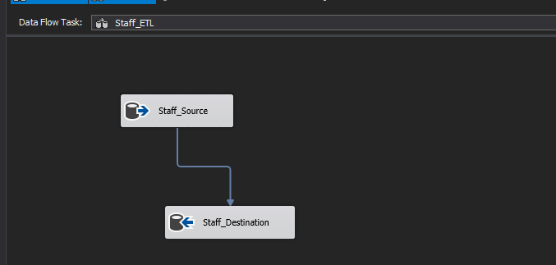
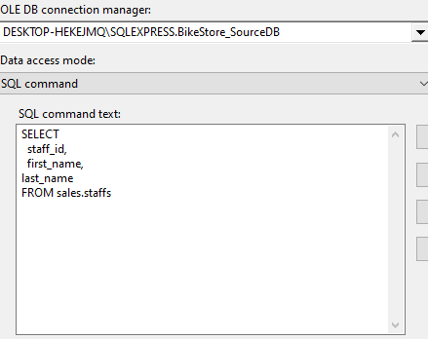

Date Dimension ETL

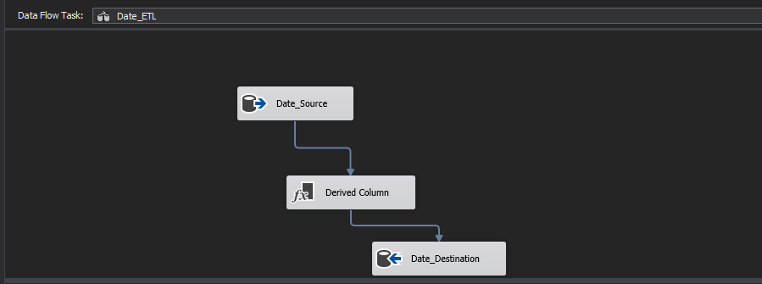

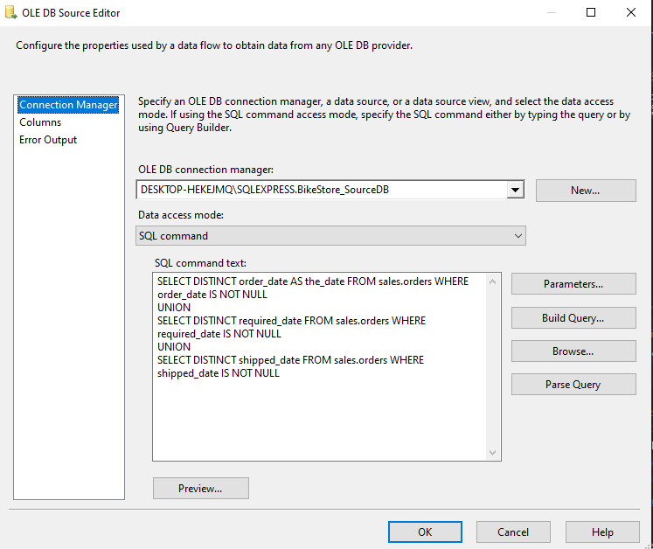

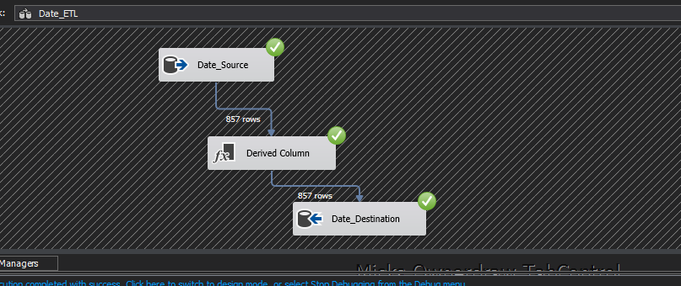

Date Dimension Explanation:
Role Playing

- Date Dimension is executed in the form of role playing in which we had three views:
  - Order date
  - Required date
  - Shipped date

- We combined all these different dates into one physical date dimension and created a special date view for each one of the three views.
- Each view will appear in the fact table as a separate table with its own FK/PK referential integrity.

Category and Brand Dimensions (Snow flaked from product)
- These dimensions are snow flaked from the product to avoid redundancy since they are highly repetitive.

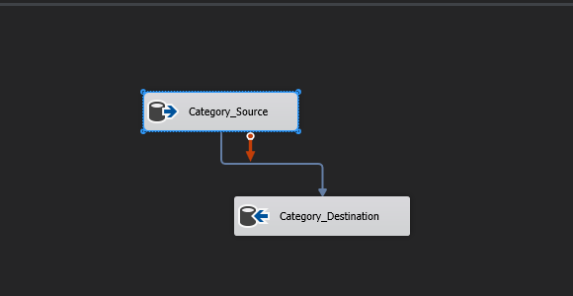

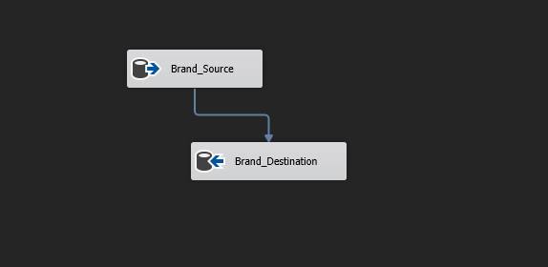

Sales Fact Table ETL

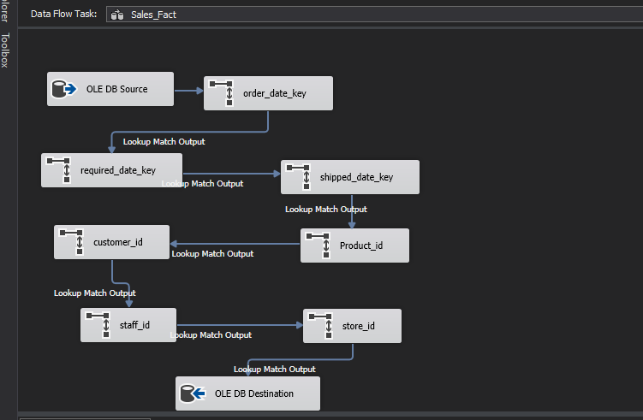
Fact Table Source SQL Command Line:
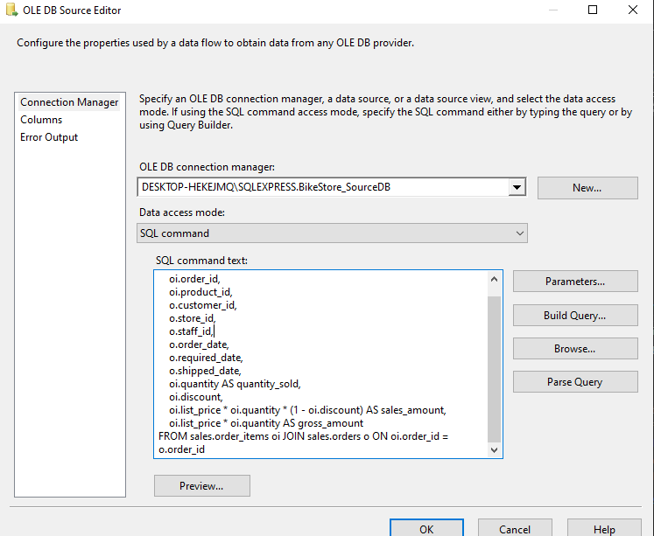

Role Playing View (Order Date) in Fact Table as Foreign Key:
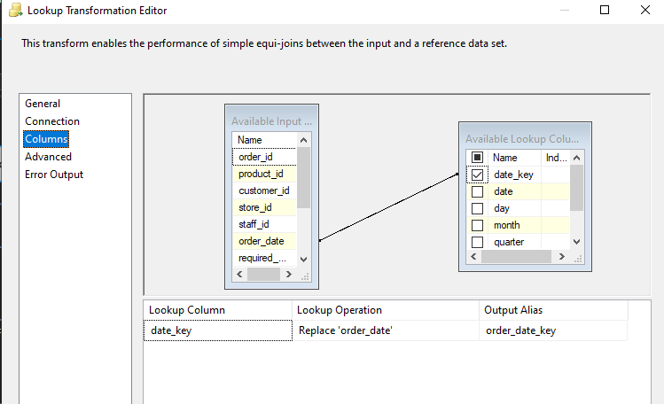
Role Playing View (Required Date) in Fact Table as Foreign Key:
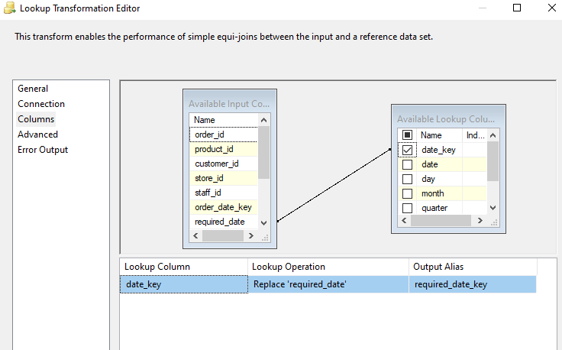
Role Playing View (Shipped Date) in Fact Table as Foreign Key:
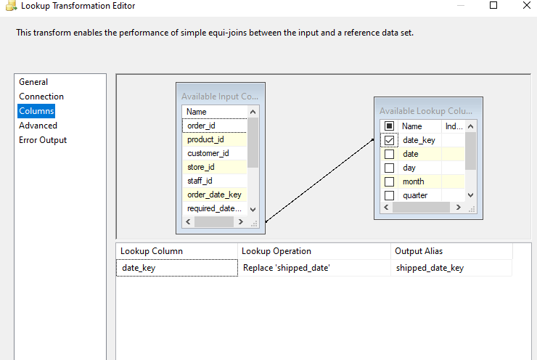

Fact Table Destination Mappings:

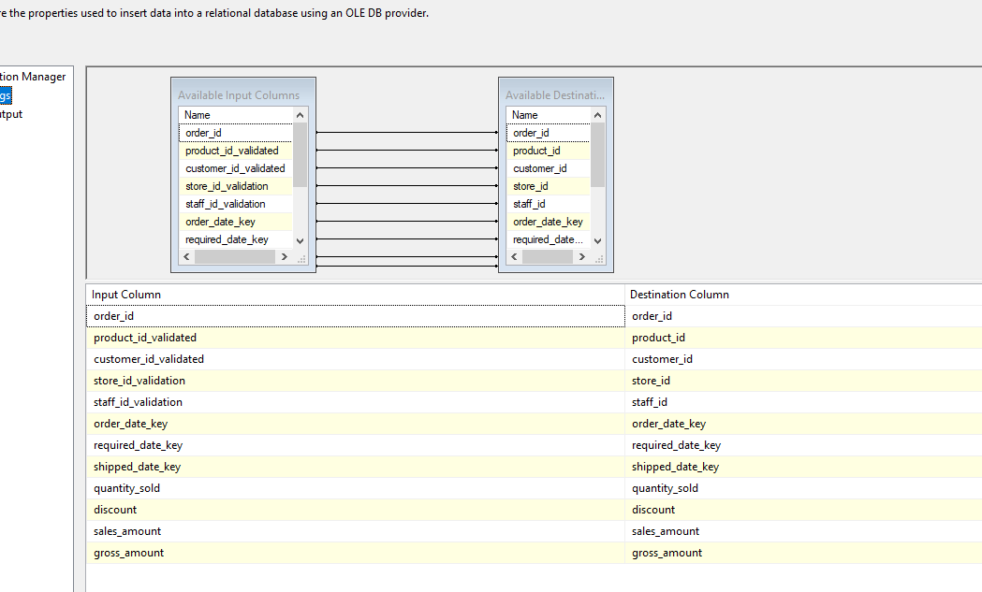
Fact Table ETL Success Run:
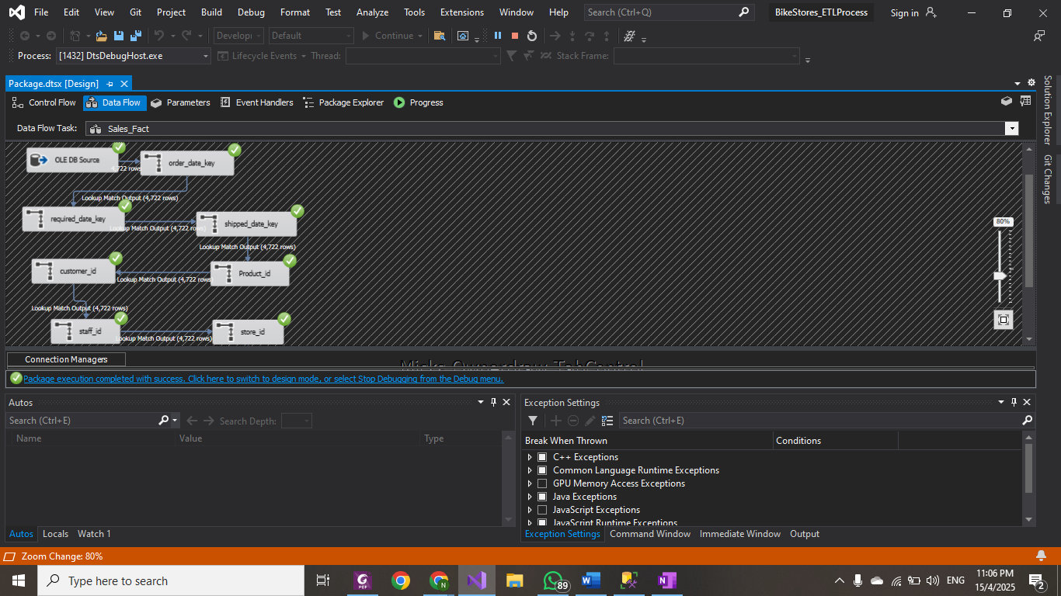

Final ETL Process Success:

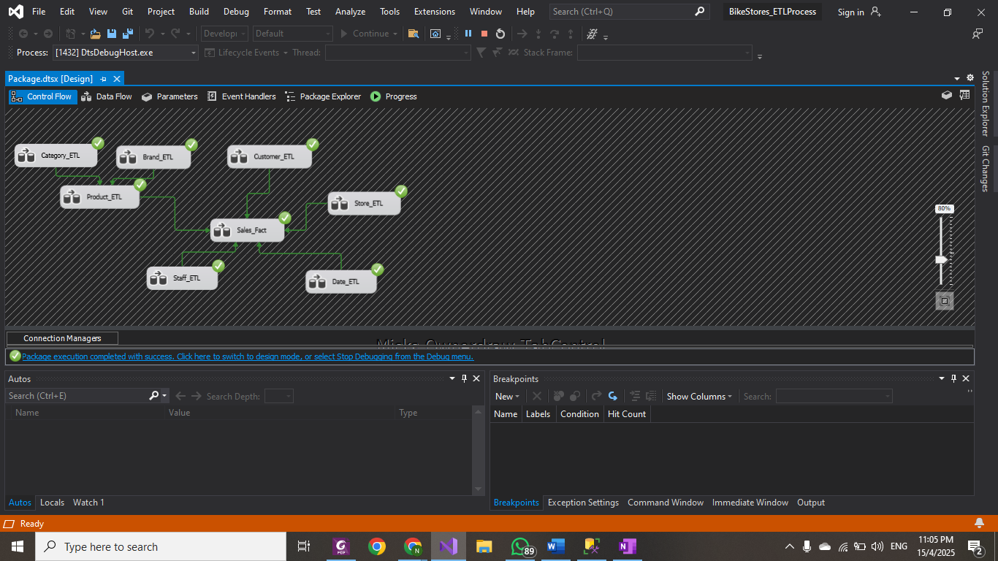
Verification of ETL Process
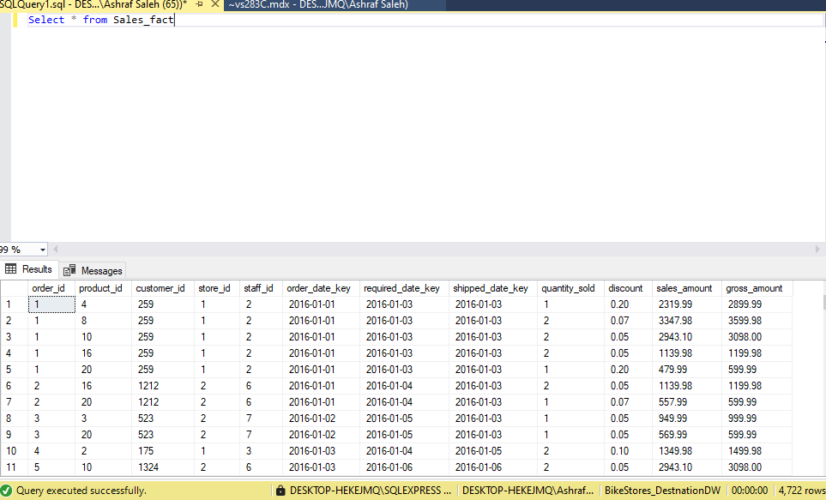

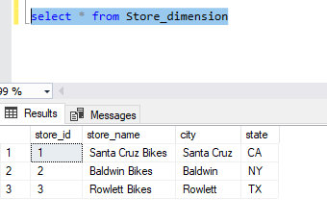

SSAS OLAP Cube Process Documentation:
Tools Used: SQL Server Analysis Services (SSAS)

OLAP Cube Setup:

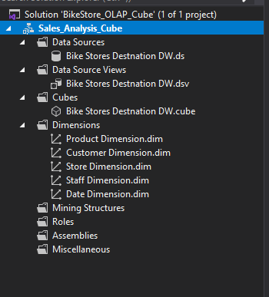
Product Dimension Attributes

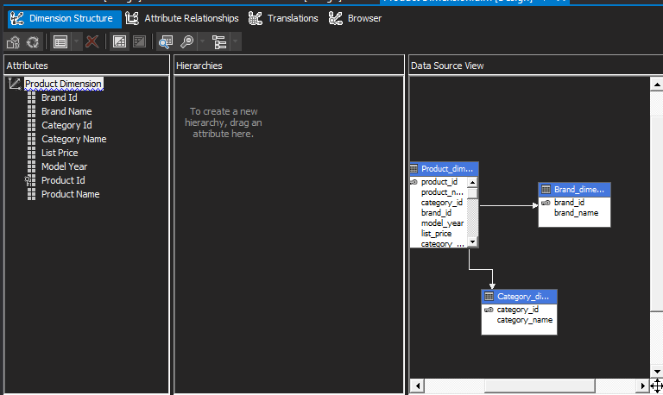

Customer Dimension Attributes
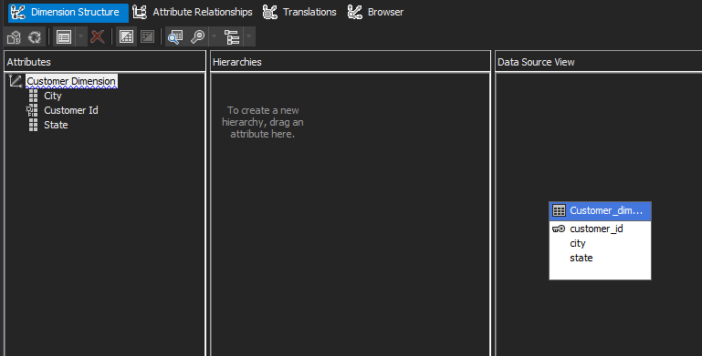
Staff Dimension Attributes
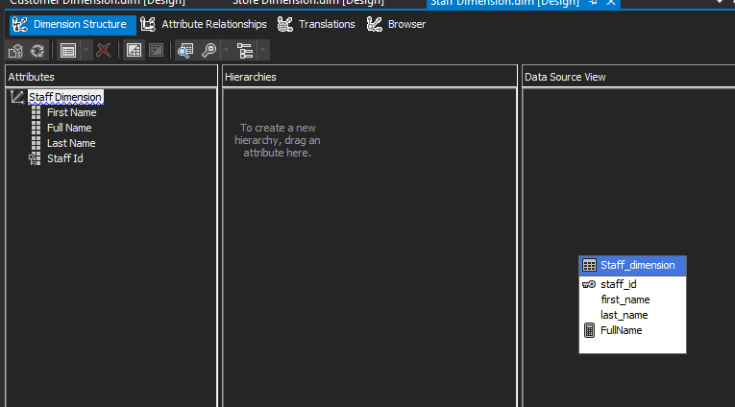
Store Dimension Attributes

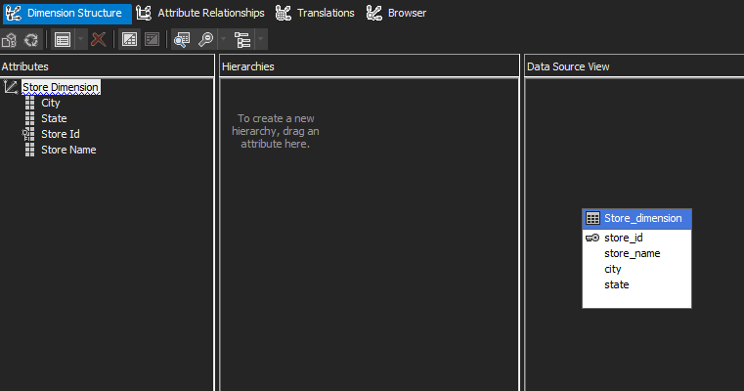

Date Dimension Attributes (Hierarchies)

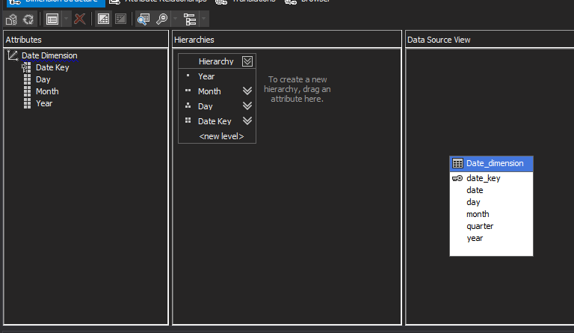

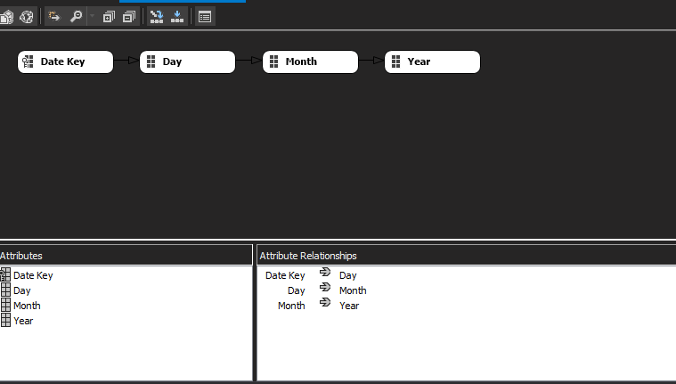

Finalized OLAP Cube:
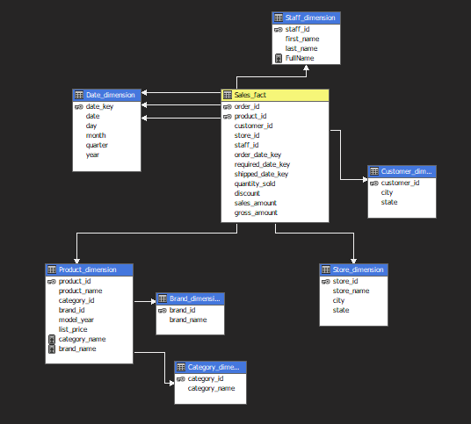
Deployment Successful

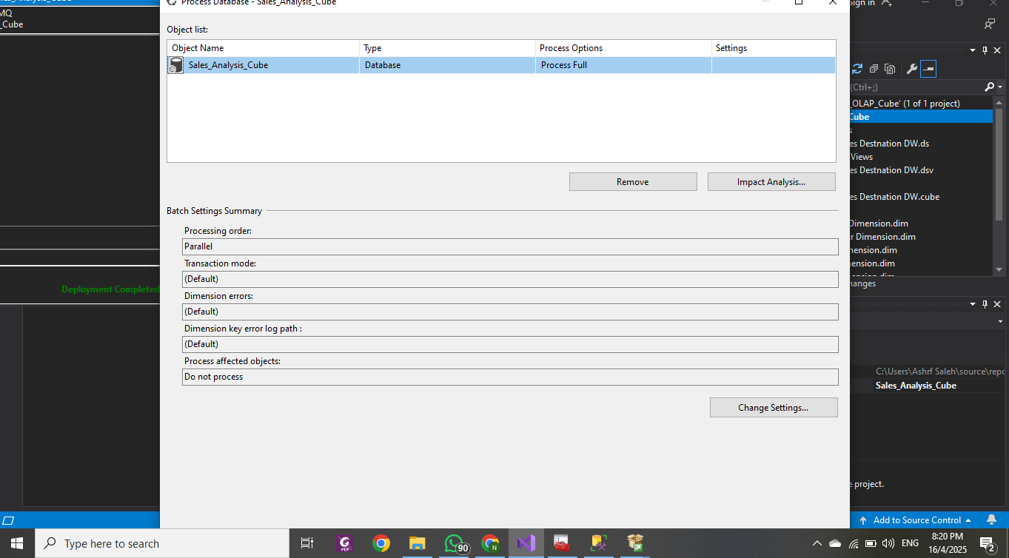

OLAP Cube Successful Run:
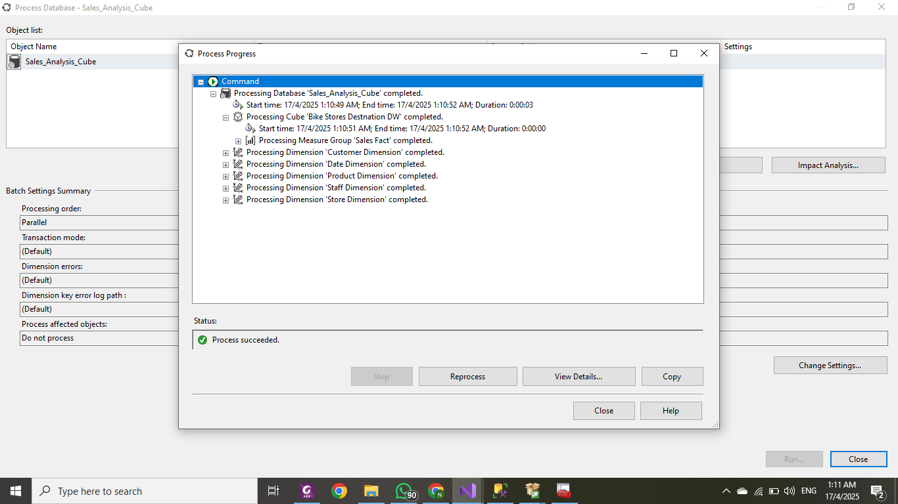
OLAP Cube Successful Verification on SSMS:

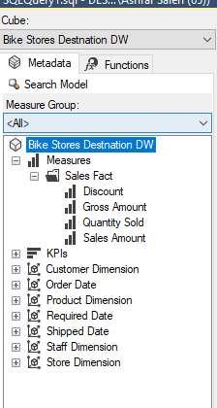

MDX Queries on the OLAP Cube Analysis:

- For each business objective, an MDX query is generated to aid in the analysis process.
- MDX queries are used on the OLAP Cube to generate multidimensional queries

1. Monthly Sales Trends

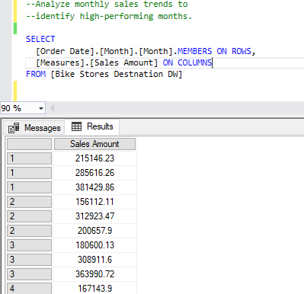
2. Yearly Sales Trends
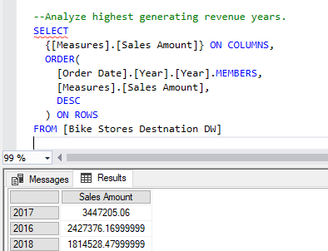

3. Top Sold Products generating revenue by Quantity Sold

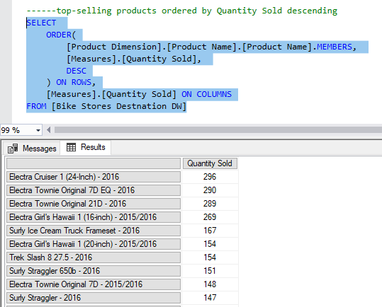

4. Top Categories generating revenue by sales amount and quantity sold.
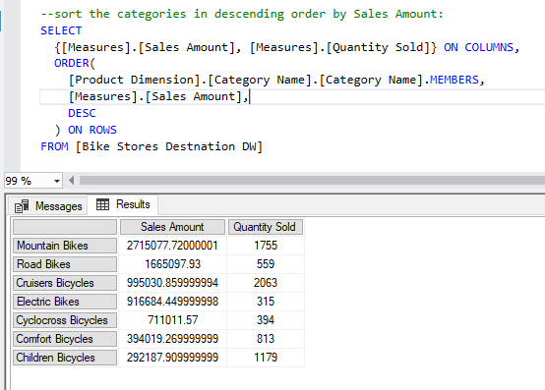

5. Top Brands generating revenue by sales amount and quantity sold

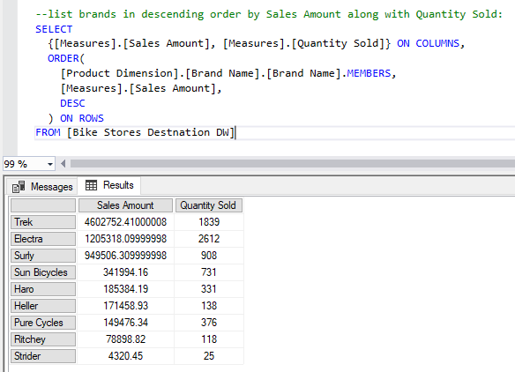
6. Top Stores generating revenue by sales amount.

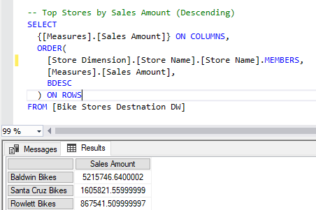

7. Top performing salespersons that generate the highest revenue

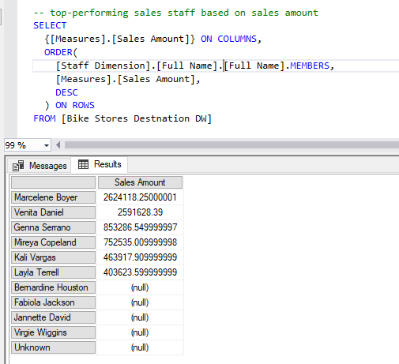
8. Highest 3 states that generate revenue based on customer demographics
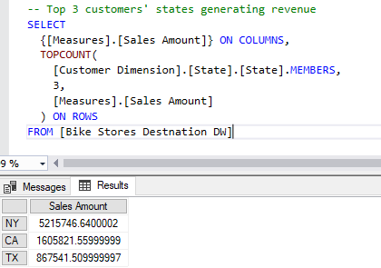

9. Top 5 Products in each brand that generates highest revenue

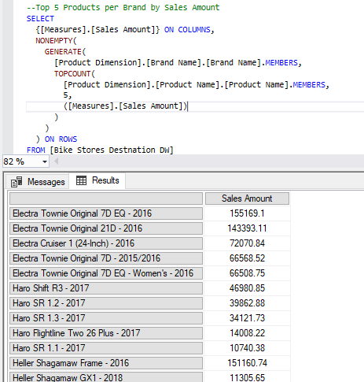

Power BI Visualization tool for Business Intelligence
Connection: Live connection to Sales_Analysis_Cube from SSAS

1. Sales amount by Year and Month:

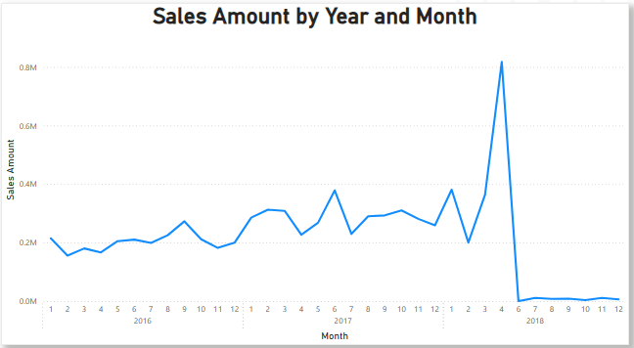

Insights:
- Consistent sales until a significant peak around April 2018, followed by a drastic drop.
- Crucial for identifying seasonal trends and demands

2. Sales amount by Category Name:
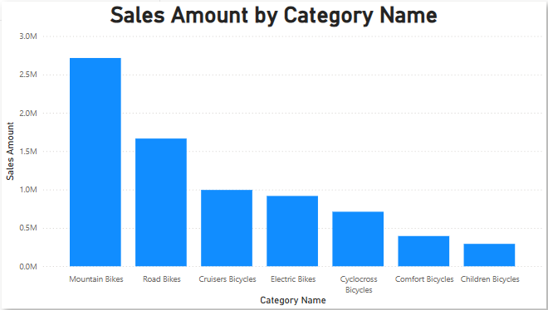
Insights:
- Mountain Bikes lead in generating revenue, followed by Road Bikes and Cruisers Bicycles.
- Indicates high-end or specialized categories of bikes yield better profitability.

3. Quantity Sold by Brand Name:

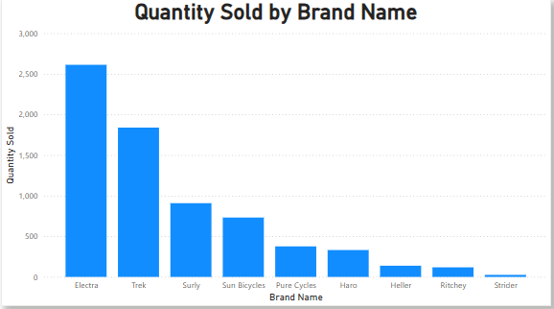

Insights:
- Electra and Trek are leading in the highest selling brands.
- Lower performing brands like Strider and Ritchey may need extra promotional support and evaluation

4. Quantity Sold by Product Name

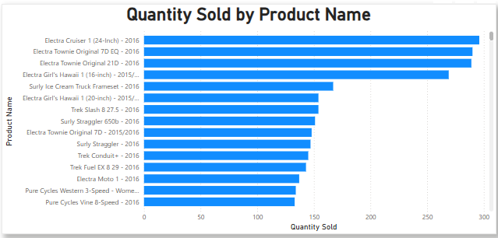

Insights:
- Top Selling products include Electra Cruiser 1 (24-inch) and Electra Townie Original 7D EQ
- Products under Electra brand dominate the list of products sold.
- Help in identifying which models are popular for future stockings and marketing campaigns.

5. Sales Amount by Store Name

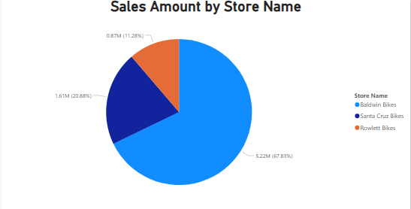
Insights:
- Baldwin Bikes accounts for 67.83% of the total sales.
- Indicates a strong and highly successful location
- May indicate where to add extra stores in which locations in a strategic expanding.

6. Quantity Sold by State
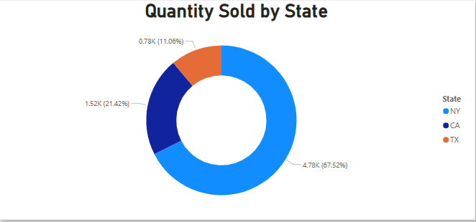

Insights:
- NY contributes with the highest volume of sales, followed by CA, and lastly TX.
7. Sales Amount by Salespersons (Staff)

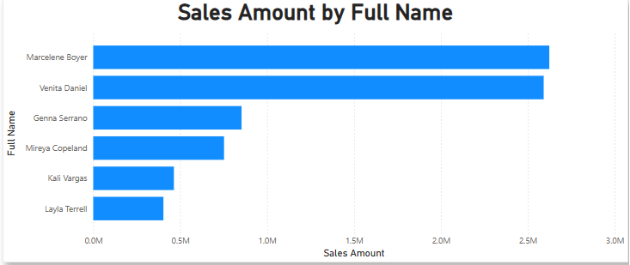
Insights:
- Marcelene Boyer and Venita Daniel are the top performers in sales.
- Can be used for sales incentives, performance reviews, or assigning key territories.

Powe BI Dashboard:
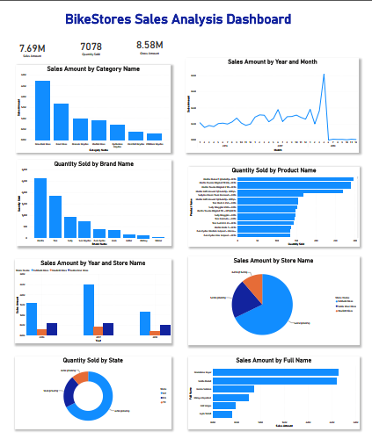
Conclusion
This project successfully demonstrates the full life cycle of a business intelligence solution, starting from the extraction of transactional and operational data from the BikeStores database, through the transformation and loading of these data into a structured data warehouse star schema using SSIS. Followed by the creation of an analytical OLAP Cube via SSAS that finally aids with the analytical querying with MDX and visualization of insights by Power BI. This project showcases how data warehousing and OLAP technologies, combined with modern visualization tools, can significantly enhance sales performance analysis, strategic planning, and business decision-making.

Workload Distribution
Data warehouse Initial Star Schema SQL DDL | All team members contributed
ETL Process | Nada Ashraf and Aly Zaki
Testing ETL Process | Ahmed Waleed and Omar Bayoumi
OLAP Cube | Ahmed Waleed and Omar Bayoumi
Testing OLAP Cube | Nada Ashraf and Aly Zaki
MDX Queries | 2 Queries per member
Power BI Visualization Charts | 2 Charts per member
Final Technical Report and PPT | All team members contributed

Resources:
Sample Database:
https://github.com/sebsto/babelfish-demo/blob/main/sql/BikeStores%20Sample%20Database%20-%20create%20objects.sql
Tools:
Microsoft SQL Server 2022: DDL Data warehouse
Visual Studio SSIS: ETL Process
Visual Studio SSAS: OLAP Cube
Microsoft SQL Server 2022: MDX Queries
Power BI: Visualizations and Charts

